General explanation of this contracted aFRR prequalification sample report:
  - This report provides an example of how a report can be drawn up. The BSP is free to deviate from the used sections and/or rename paragraph or chapter titles. However, all sections included in this example report should also be found in the report provided by the BSP. Therefore, it is recommended to adhere to the structure of this document as much as possible.

Description:
Cover page with company details, document name and date.

Pre-qualification test

contracted aFFR

The Frequency Company
Frequency Lane 50; 5000 HZ ENDZOEE
www.thefrequencycompany.mhz
+31 88 50200

Revision Management

Insert revisions here. The following is an illustration. Here should be included at least:
- Current version with date, authors and changes
- Previous version with date, authors and changes
- Number of pages

REV | DESCRIPTION | DATE | AUTHOR | CHECK | EXTERNAL | APPROVAL
0 | Initial version | Dec 01, 2019 | F.R. Equency | F.E.
1 | final | 01 Jan 2020 | S.U. Port | S.P.

Distribution: |  | Number of pages including  cover page and annexes:  11 | Revision:  1

Contents
Add a table of contents here. The following is an illustration.

1 Contents 3
2 Introduction 4
2.1 Purpose of the pre-qualification test 4
2.2 Power and directions to be pre-qualified: 4
2.3 List of persons involved in the test: 4
3 Description of the installations 5
3.1 Bidding requirements 5
4 Test description and results 6
4.1 Test moment 6
4.2 Test: 24 hours bidding 6
4.3 Test: Bids activation 7
4.3.1 Upward activation 1 7
4.4 Details 10
5 Conclusion 11
6 Annexes 12

Introduction
Write your own introduction here.

This prequalification test was carried out within the framework of the provision of contracted automatic Frequency Restoration Reserves (contracted aFRR) by The Frequency Company (hereafter: TFC) to TenneT TSO B.V. (hereafter: TenneT).
Since DD/MM/YYYY, TFC is pre-qualified for the provision of regulating power through voluntary bids.

Supplier address: The Frequency Company
Frequency Lane 50;
5000 HZ ENDZOEE
+31 88 50200

Purpose of the pre-qualification test
The purpose of the test is to demonstrate that installation(s) of the TFC as a whole meet the requirements related to the delivery of contracted aFRR.
A BSP approval for voluntary energy bids is a requirement for the prequalification for contracted energy bids.
Instead, all the extra aspects specifically required for contracted aFRR – as specified in the "aFRR Manual for BSPs" – will be described.

Power and directions to be pre-qualified:
Select (only) one option and specify the amount to be prequalified:
- Upward regulation
____ MW
- Downward regulation
____ MW
- Upward and downward regulation
____ MW (up) and ____ MW (down)

List of persons involved in the test:
Name | Organization
Mr. F.R. Equency | TFC
Mr. S.U. Port | TFC

Description of the prequalified volume

Installation(s) details and bidding requirements
Describe the composition of the assets that will be used for the bids. In particular, specify how you can guarantee that there will be bids for 24 hours as specified in the requirements.

Test description and results
A description of the test and of its results are reported in this chapter, along with several graphs and tables. The values in the tables should correspond to the original time-synchronous measurement data. Also the date and the time should be clearly indicated in the test. This chapter should also contain a description of any deviations or peculiarities that can be seen in the graph or table or that appear in the (separately) supplied measurement data.

Note: The graphs and tables should by themselves be sufficient for TenneT's assessment of the prequalification. Please ensure that the graphs are correctly scaled and that the indications on the axes are clearly reported.

Test moment

Include in the table below the aligned period of the pre-qualification test.

Date and time of test start:
Date and time of end of test:

Test: 24 hours bidding
Describe the adopted bidding strategy, specifying the bidded amounts (in both directions) and all the activations.
Include an overall graph (see example below) where your bidding strategy is visible, together with all the activations.
Specific details about the single activations shall be provided only in the next section.

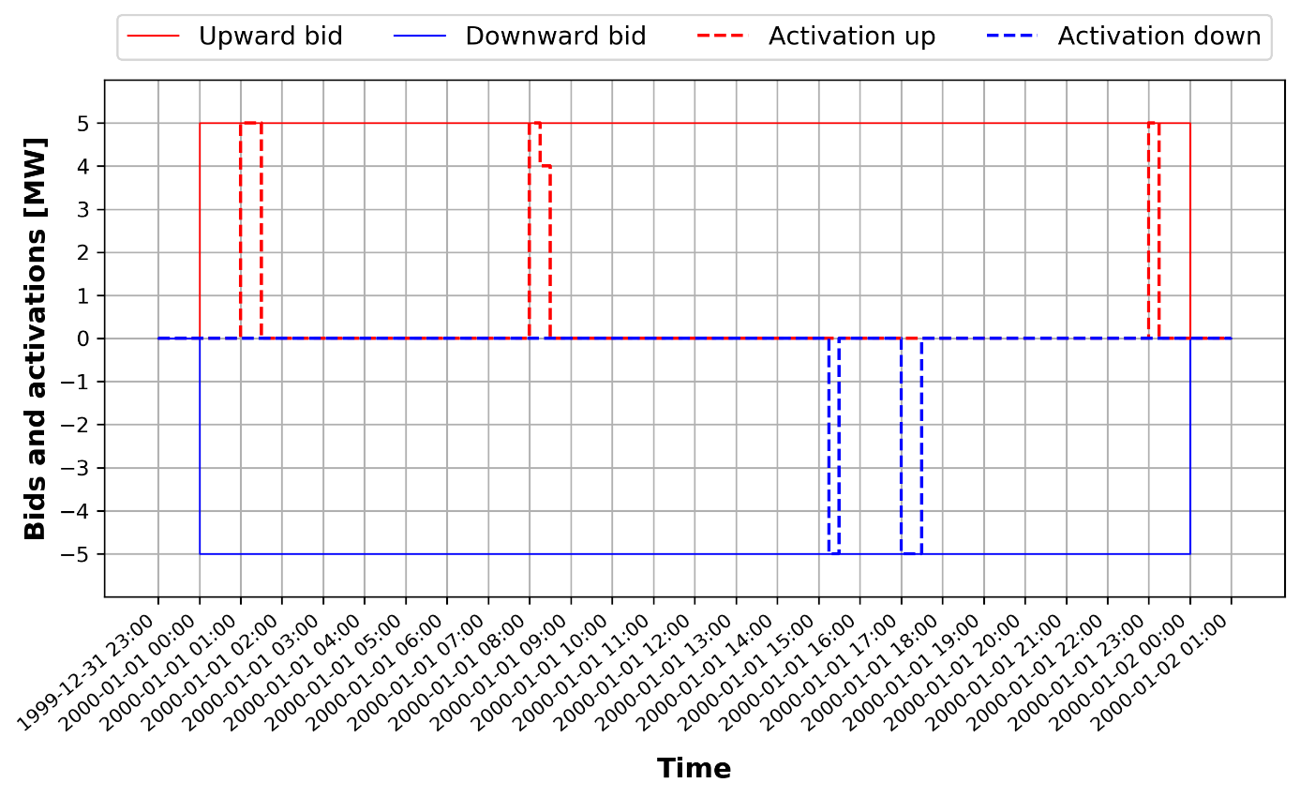

Test: Bids activation

In this section, 2 activated bids shall be described in the upward direction and another 2 shall be described in the downward direction. Also any other activation that (for any reason) deviates from normal operation or the set requirements should be described, providing a plot and a table as well.

Upward activation
The description below is an example and illustrates one of the activations to be described. In this case, it is the description of an upward activation. The same structure shall be used for the downward activations as well

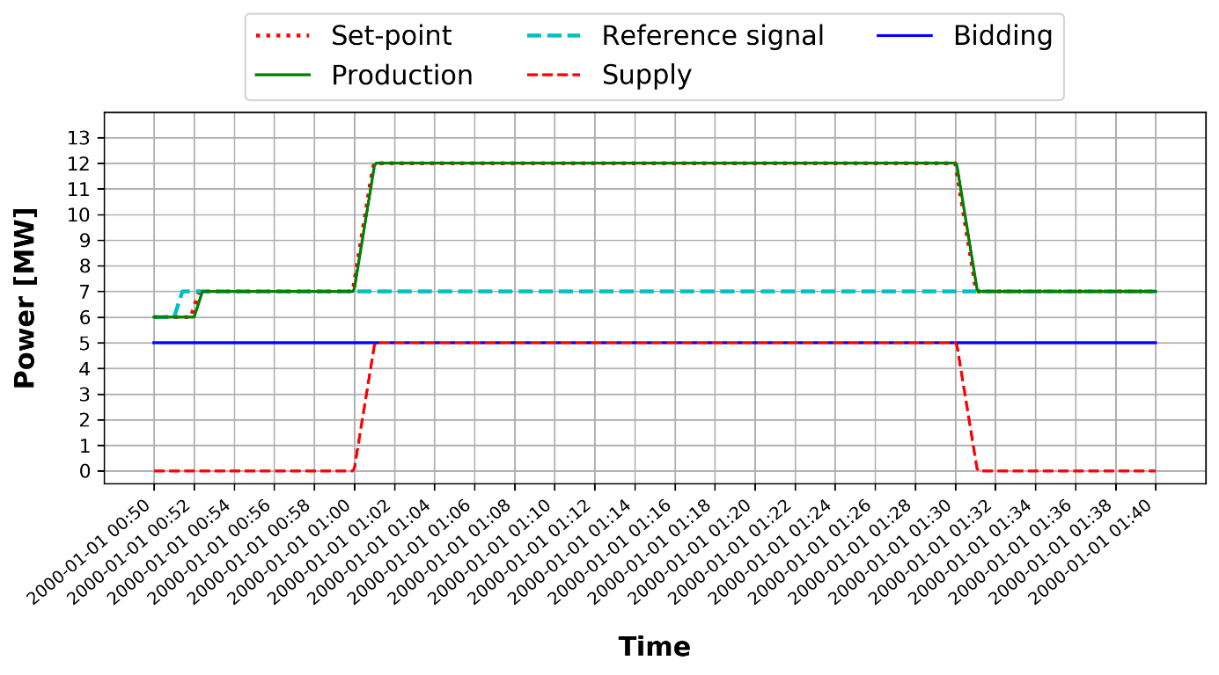

Description | Time  (seconds) | Reference signal  (MW) | Setpoint  (MW) |  | Sum of production capacity  (MW) | Power change  (Ref - Sum Prod.)  (MW)
Start of test
Start set point
First power change noticeable (min. after 30 sec)
Time of qualified Power of test setpoint
Maximum power achieved (during set point presence)
Average power achieved (during set point presence)
Minimum power achieved (during setpoint)
End of set point
First power change noticeable (min. after 30 sec)
Return time on reference signal

Downward activation
See previous section.

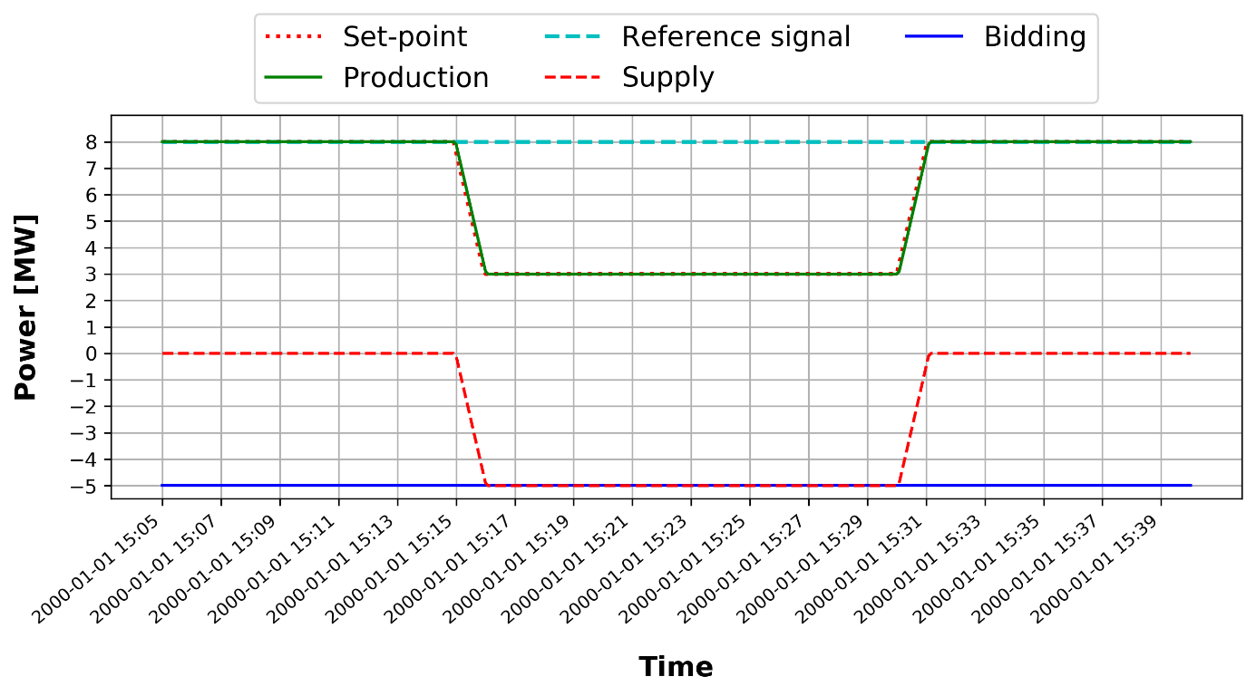

Description | Time  (seconds) | Reference signal  (MW) | Setpoint  (MW) |  | Sum of production capacity  (MW) | Power change  (Ref - Sum Prod.)  (MW)
Start of test
Start set point
First power change noticeable (min. after 30 sec)
Time of qualified Power of test setpoint
Maximum power achieved (during set point presence)
Average power achieved (during set point presence)
Minimum power achieved (during setpoint)
End of set point
First power change noticeable (min. after 30 sec)
Return time on reference signal

Details

If there are any peculiarities or different behaviours than expected, please explain this in this paragraph.

Conclusion
Report here findings and conclusion about the achievement of the subtests and the final conclusion.

Annexes
Include any attachments here.

