General explanation of this aFRR prequalification sample report:
  - This report provides an example of how a report can be drawn up. The BSP is free to deviate from the used sections and/or rename paragraph or chapter titles. However, all sections included in this example report should also be found in the report provided by the BSP. Therefore, it is recommended to adhere to the structure of this document as much as possible.

Description:
Cover page with company details, document name and date.

Pre-qualification test aFFR

The Frequency Company
Frequency Lane 50; 5000 HZ ENDZOEE
www.thefrequencycompany.mhz
+31 88 50200

Revision Management

Insert revisions here. The following is an example. Here should be included at least:
- Current version with date, authors and changes
- Previous version with date, authors and changes
- Number of pages

REV | DESCRIPTION | DATE | AUTHOR | CHECK | EXTERNAL | APPROVAL
0 | Initial version | Dec 01, 2019 | F.R. Equency | F.E.
1 | final | 01 Jan 2020 | S.U. Port | S.P.

Distribution: |  | Number of pages including  cover page and annexes:  12 | Revision:  1

Contents
Add a table of contents here. The following is an example.

1 Contents 3
2 Introduction 4
2.1 Purpose of the pre-qualification test 4
2.2 List of persons involved in the test: 4
3 Descriptions 5
3.1 Brief description of BSP and installations in the portfolio 5
3.2 Portfolio composition 5
3.3 Description of the scheme 5
3.4 Total net production / Portfolio measurement 5
3.5 Reference signal/reference signals 5
3.6 Setpoint(s) 5
4 Description of technical capability of delivery 6
4.1 Test moment 6
4.2 Installation data 6
4.3 Setpoint 6
5 Test results 7
5.1 Test: aFRR 7
5.2 Details 10
6 Conclusion 11
7 Annexes 12

Introduction
Write your own introduction here.

This prequalification test was carried out within the framework of the provision of Automatic Frequency Restoration Reserves (aFRR) by The Frequency Company (hereafter: TFC) to TenneT TSO B.V. (hereafter: TenneT).

Supplier address: The Frequency Company
Frequency Lane 50;
5000 HZ ENDZOEE
+31 88 50200

Purpose of the pre-qualification test
The purpose of the test is to demonstrate that installation(s) of the TFC as a whole meet the requirements related to the delivery of voluntary bids aFRR.

List of persons involved in the test:
Name | Organization
Mr. F.R. Equency | TFC
Mr. S.U. Port | TFC

Descriptions

Brief description of BSP and installations in the portfolio

Give a short description of the type of installations and the (organisational) way in which cont(r)acts are maintained. In addition, outline which agreements are made with the installations and where the responsibilities lie in the organisation of the BSP.
Note: The description in this chapter is generic. Information and details that are more specifically related to the test situation must be specified in chapter 4.

Portfolio composition

Describe what the portfolio consists of.

Description of the scheme

Give a general description of the regulation and control of the portfolio and the installations. If a limited energy source is used, the description should also include how a sufficiently long supply will be guaranteed, for example by describing the charging strategy.

Include (the processing of) the requested signals (see §6.5 of the aFRR product information):
From TenneT to BSP
- Upward regulation delta-setpoint
- Downward regulation delta-setpoint
- Frequency deviation (if applicable)
- Heartbeat signal

From BSP to TenneT
- Total net production
- Reference signal (or if agreed: reference signals)
- Verification upward delta-setpoint
- Verification downward delta-setpoint
- Verification heartbeat signal

Total net production / Portfolio measurement

Explain here how total net production is reached and processed, including any aggregation of individual plants. See the aFRR handbook for an explanation of the requirements.

Reference signal/reference signals

Explain specifically how the reference signal is created. It is important to show clearly how the expected production capacity (total net production) excludes any possible incorporation of aFRR (de)activations. See the aFRR manual for further explanations of the requirements.

Setpoint(s)

Explain how the setpoint is processed during normal operation and how no interference with the reference signal is ensured.

Description of technical capability of delivery
This chapter describes (the composition of) the (portfolio of) assets to be prequalified. This must include information about the composition of the prequalified power.

Test moment

Include in the table below the aligned period of the pre-qualification test.

Date and time of test start:
Date and time of end of test:

Installation data

The table below may also be provided as a separate document (for example, by marking the TIs to be used during the test in the PQ Application Form).

Note: Make sure that no personal information (such as an EAN18) is included in this table.

Give an overview of the Technical Installations (TI) for which prequalification is requested and the capacity per TI, as agreed in advance with TenneT. It must also be described whether components with a limited energy source are present, such as batteries. In addition, the grid connection/connection level on which the delivery takes place should be included.

Technical installation  (-) | Power  (MW) | Test date  (dd-mm-yyyy)
X | 0.1 | 01-01-2021
Y | 20 | 01-01-2021
… | … | …
Table 1. Overview of facilities prequalification test.

Setpoint

Explain here how the setpoint was generated during the test. It is allowed to deviate from the described example (in chapter 5), as long as the requirements of chapter 5 are met.

Test results
The results of the test are reported in this chapter along with several graphs and a table. The values in the tables should correspond to the original time-synchronous measurement data. Also the date and the time should be clearly indicated in the test. This chapter should also contain a description of any deviations or peculiarities that can be seen in the graph or table or that appear in the (separately) supplied measurement data.

Note: The graphs and tables should by themselves be sufficient for TenneT's assessment of the prequalification. Please ensure that the graphs are correctly scaled and that the indications on the axes are clearly reported.

Test: aFRR

The description below is an example and illustrates a test to be carried out for a prequalification in both the up and down direction. A prequalification test in only one direction is also possible. Please replace this with your own description that complies with the currently applicable product specifications.

The test that can be performed is described below and broken down as follows (see the graphs after the description for graphical representation):
- It starts with a normal situation where the reference signal is given.
- After 60 seconds the setpoint is sent (how TFC does this is up to them). The ramp rate of at least 7% must be achieved, so that the qualified power is reached after a maximum of 15 minutes.
- After the qualified power is reached (after a maximum of 15 minutes), the power should be held as long as necessary to show that the qualified power is delivered stably (in the example in chapter 6 this is 2 minutes).
- After this the setpoint is brought to 0 and the same ramp rate (of at least 7%) is achieved.
- After the qualified power has been re-established, after a maximum of 15 minutes, the power should be held as long as necessary to show that the qualified power is being delivered stably (in the example in chapter 6 this is 2 minutes). The power to be delivered is now equal to the reference signal.
- After this, a negative setpoint of the ramp rate of at least 7% is sent. After a maximum of 15 minutes the power (reference power - qualified power) should be reached.
- After the qualified power is reached (after a maximum of 15 minutes), the power should be held as long as necessary to show that the qualified power is delivered stably (in the example in chapter 6 this is 2 minutes).
- After this, the setpoint is set to 0 and the same ramp rate (of at least 7%) is achieved.
- After the qualified power is reached (after a maximum of 15 minutes), the power should be held as long as necessary to show that the qualified power is delivered stably (in the example in chapter 6 this is 2 minutes).
- End of the test

Note: The above text may be removed from the pre-qualification report. It is included here for clarification purposes only.

The figures below are based on the above described tests. The details in the graph (e.g. the time duration) are included only for illustrative purposes and are not representative of the requirements asked.

Graphs are expected to clearly show the start of the test, the reference signal (without a setpoint), the activation and the end of the test. Normally, 5 graphs per direction are desirable: total overview, start step [2], stable situation (upward control) [3], return step [4], stable situation (after return step) [5].

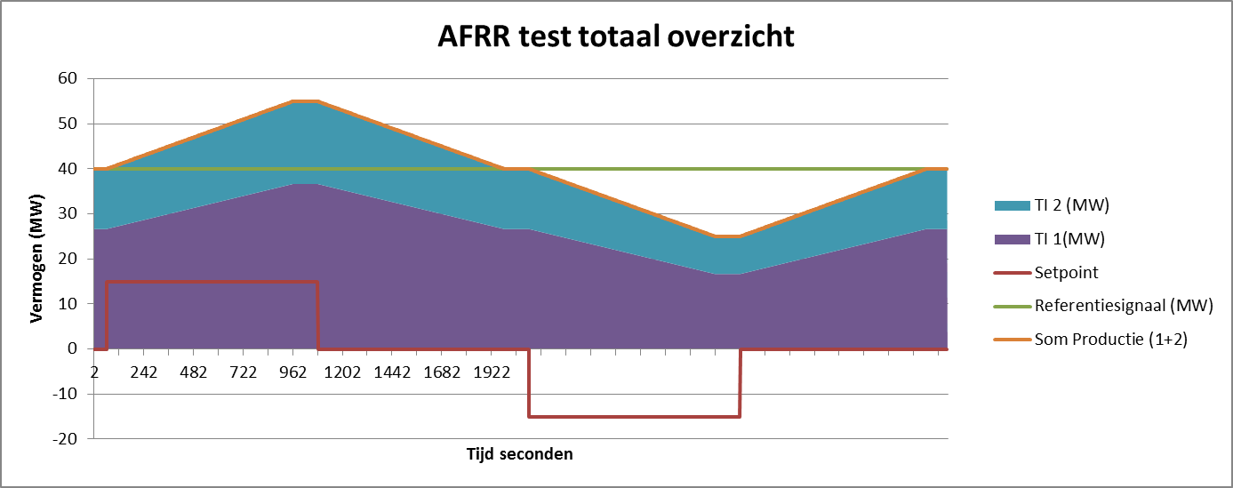
9
10
8
7
5
6
2
3
4
1

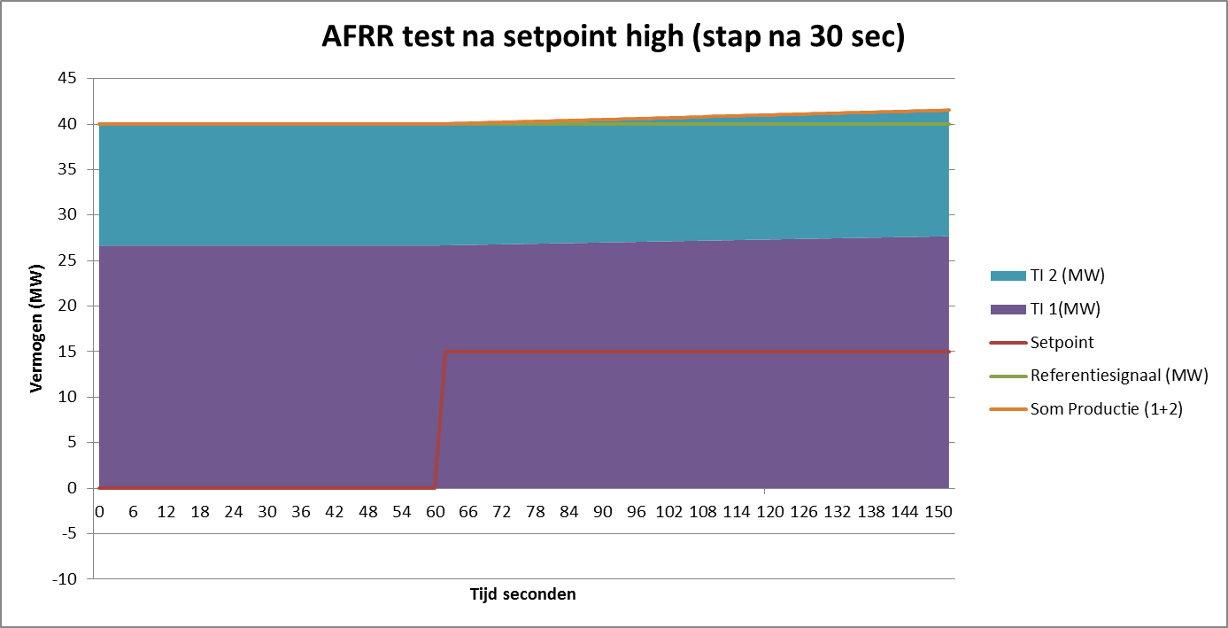
1
2

Description | Time  (seconds) | Reference signal  (MW) | Setpoint  (MW) | Sum of production capacity  (MW) | Power change  (Ref - Sum Prod.)  (MW)
Start of test
Start set point
First power change noticeable (min. after 30 sec)
Time of qualified Power of test setpoint
Maximum power achieved (during set point presence)
Average power achieved (during set point presence)
Minimum power achieved (during setpoint)
End of set point
First power change noticeable (min. after 30 sec)
Return time on reference signal
Time setpoint negative
First power change noticeable (min. after 30 sec)
Time of qualified Power of test setpoint (MW)
Maximum power achieved (during set point presence)
Average power achieved (during set point presence)
Minimum power achieved (during setpoint)
End of set point
First power change noticeable (min. after 30 sec)
Return time on reference signal

Details

If there are any peculiarities or different behaviours than expected, please explain this in this paragraph.

Conclusion
Report here findings and conclusion about the achievement of the subtests and the final conclusion whether the ramp rate is feasible.

Annexes
Include any attachments here.

It may be chosen to test with a ramp rate (≥20%) that meets a 5-minute FAT (Full Activation Time) to meet future requirements.

